INTERNATIONAL TOURISM

The Department of Intercultural Communication and International Tourism

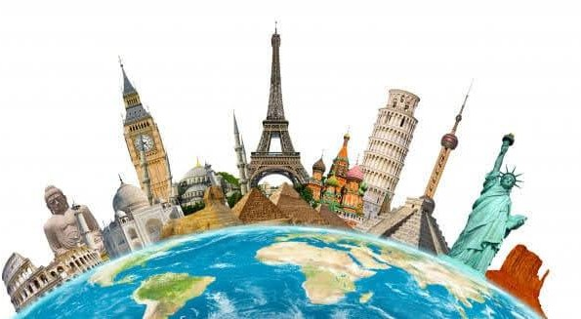
November, 2023

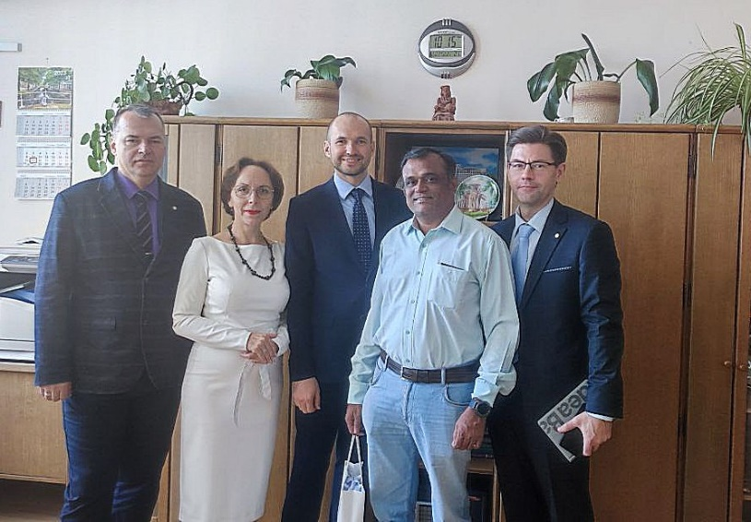

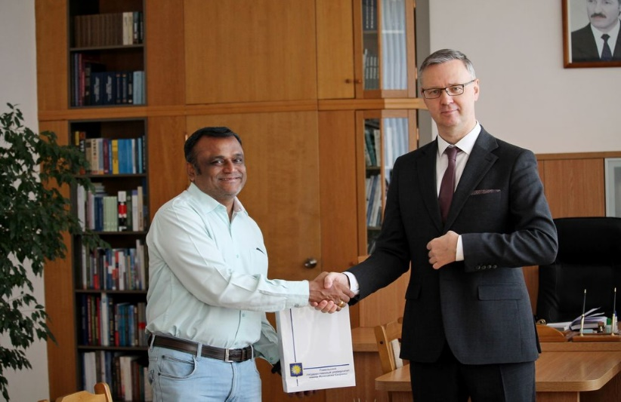

What’s new?

Francisk Skorina Gomel State University was visited by a head of International department of Ajeenkya DY Patil university Dr. Vijayakumar Varadarajan. The university is located in Pune, State of Maharashtra. A representative of the Indian partner university met with rector Sergei Khakhomov and also visited the Faculty of Economics of our university. During the visit, the main areas of cooperation between the two universities were identified: academic exchange of students and teachers, organization of online lecture series, joint scientific conferences and joint scientific research.

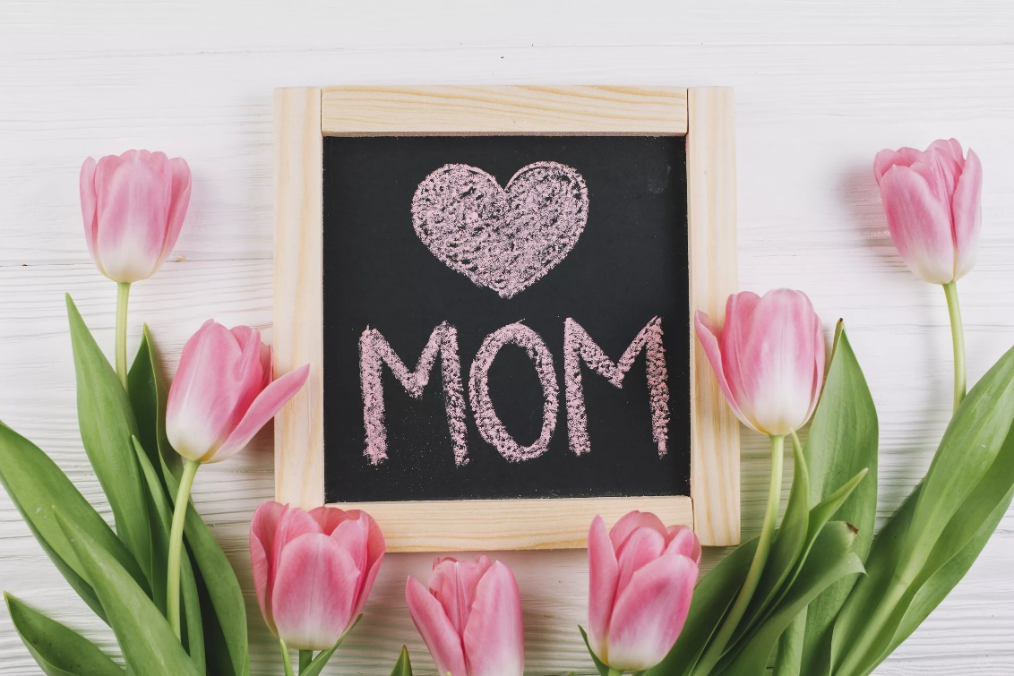

A heartwarming list of the sweetest Mother’s Day traditions around the world

Mother’s Day is special. Celebrations, and even the dates, differ widely by country and culture. Let’s find out how some of the countries around the world celebrate Mother’s Day. And how these can inspire you to make the day even more special for your mamma this year.

Peru

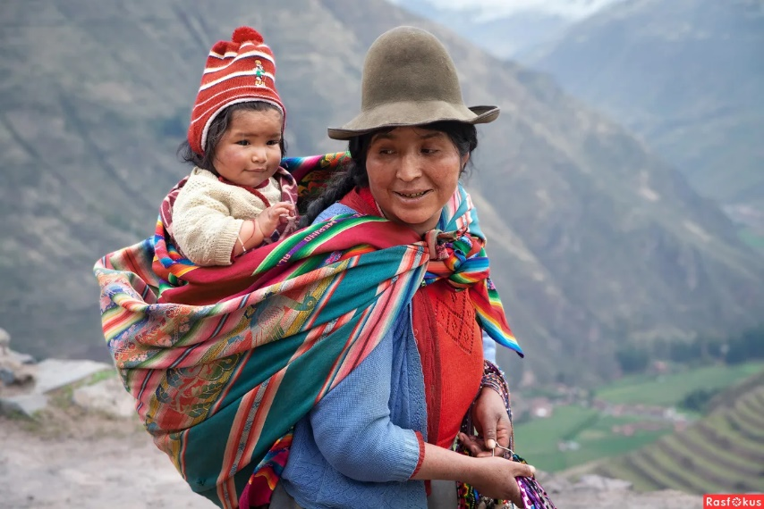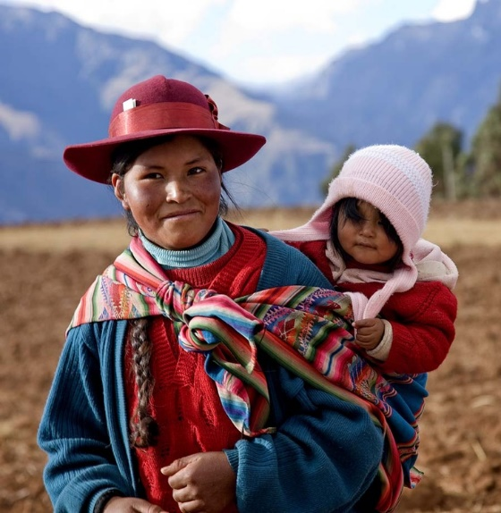

Mother’s Day in Peru is quite a tradition. Instead of just one day, it is celebrated for a week here. Families organize dinners, lunches, parties, and trips throughout the week. Art and musical performances are common around the city. Plus, mothers can visit museums, exhibitions, and festivals for free during this week. Children shower their mothers with flowers and gifts. And recite poems and stories for them!
One very unique aspect of mother’s day celebrations in Peru is that they honor their dead mothers too. People visit the graves of their deceased mothers, grandmothers, and wives and offer flowers and balloons. Peru is probably the most enthusiastic one about mother’s day celebrations. 7 days! Wow, that is long and fun!

Bring Peru home this Mother’s Day
How about organizing a week-long party for your mom as the Peruvians do? Help her with her chores, shower her with presents, and do something special for her every day.
Organize art exhibits and home museums that your mom to attend for free! This could include a walk down the memory lane for your family!

UK

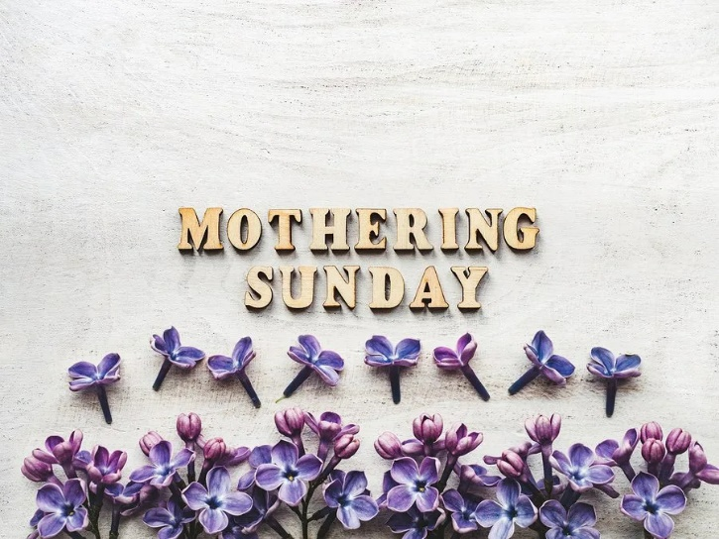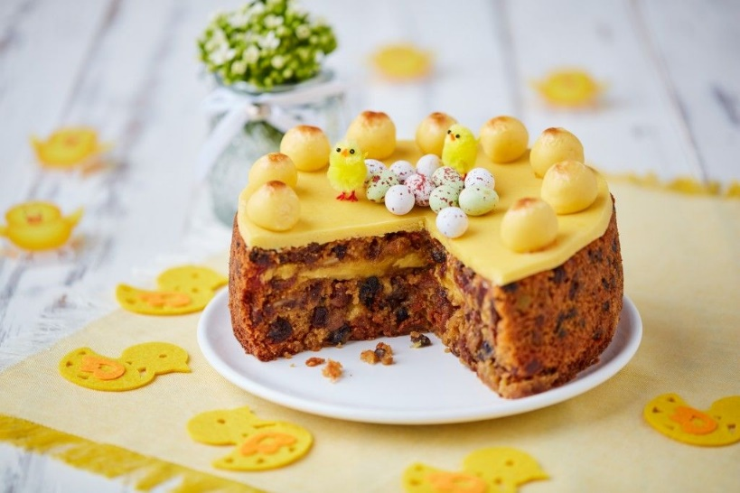

Mother’s Day in the UK is celebrated on the 4th Sunday of Lent every year. That means it is like a couple of months ahead of the American Mother’s Day. UK’s mother’s day is also known by a different name. It is called Mothering Sunday.
Earlier, the day had nothing to do with mothers in the UK. Instead, it was a day when Christians would visit their “mother” church. But as focus shifted from religion, Mothering Sunday in the UK came to be associated with the mothers of the family. Now, the British honor and celebrate their mothers on this festive day.
Children usually gift cards and flowers to their mothers. And make them breakfast in bed. Traditionally Mothering Sunday in the UK has revolved a lot around good food. One of the most important rituals is to prepare a Simnel Cake that is relished by the entire family. Pancakes and other yummy treats are also loved.

Bring home the UK this Mother’s Day
Bake a traditional Simnel Cake.
Make mom some great breakfast in bed.

Italy

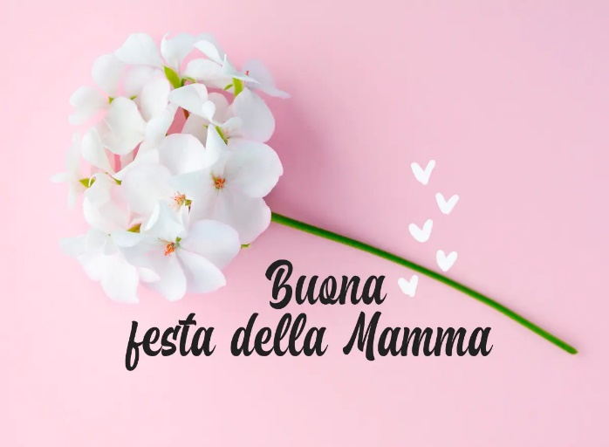

Mother’s day is known as La Festa della Mamma in Italy. Italian mamma is the most important person in the house. She is kind of celebrated throughout the year. But on Mother’s Day, she is definitely pampered and appreciated more.
La Festa della Mamma is celebrated on the second Sunday of every May. Celebrations are simple. Family members try to get together and indulge their moms. If you cannot get home, you have to call. Small gifts, fresh flowers (often roses), and handwritten poetry are common. Cards are not that common in Italy.
The day starts with a simple breakfast. Then, the family heads out for lunch to give mamma a day off from cooking. Mother’s day ends with a dessert, mostly a cake in the heart shape! Cute, isn’t it? In Italy, it is more about spending quality time with your mom than anything else. And making her feel like the queen, of course!

Bring Italy home this Mother’s Day
Spend time with your mom. Help her with her chores, watch a movie, or go out together. Let her know she is appreciated.
Gift her a rose and bake a heart-shaped cake. I am sure she will love that.

France

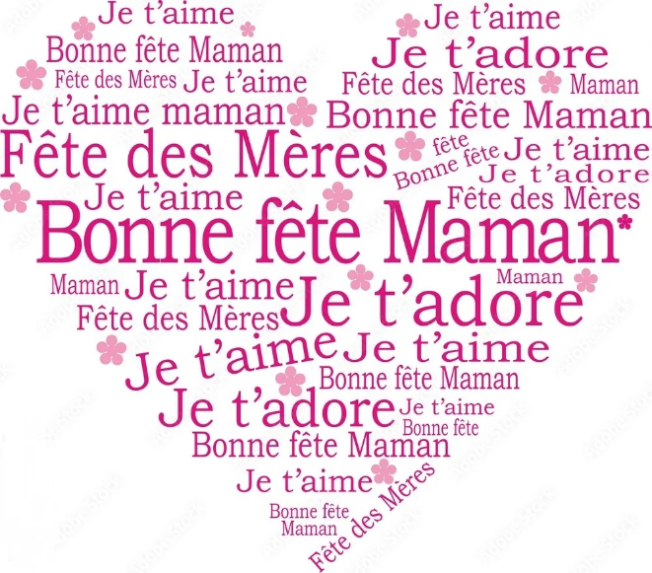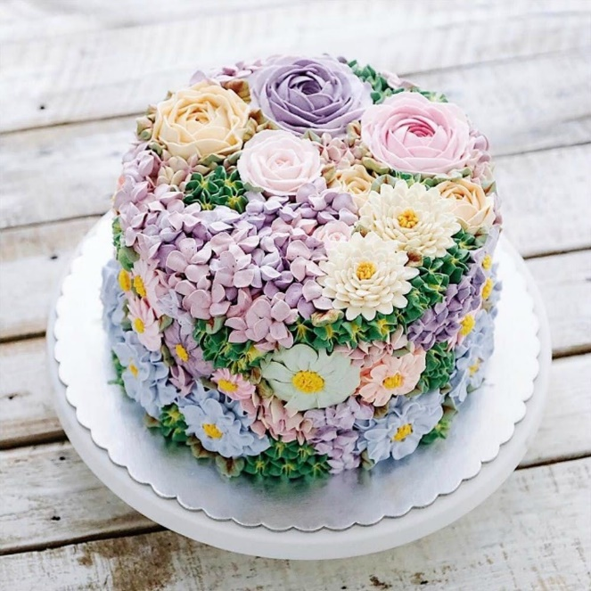

Mother’s Day in France is celebrated either on the last Sunday of May or the first Sunday of June. The idea of a Mother’s Day in France originated during the Napoleonic era when families with a large number of children were presented with medals. Some localities still honor this tradition and present moms with medals on Mother’s Day.
On a personal level, it is traditional to present your mom with a special flower bouquet cake. In other words, a cake that is shaped like a flower bouquet. An intimate family dinner is pretty common too. Children offer flowers, perfumes, jewelry, or chocolates to their moms. As well as handmade gifts and handwritten poems.

Bring France home this Mother’s Day
Bake a flower bouquet cake for your mom. And arrange for a lovely family dinner at home or at a restaurant.
For fun – have an award ceremony where you give out medals for your mother’s various achievements.

India

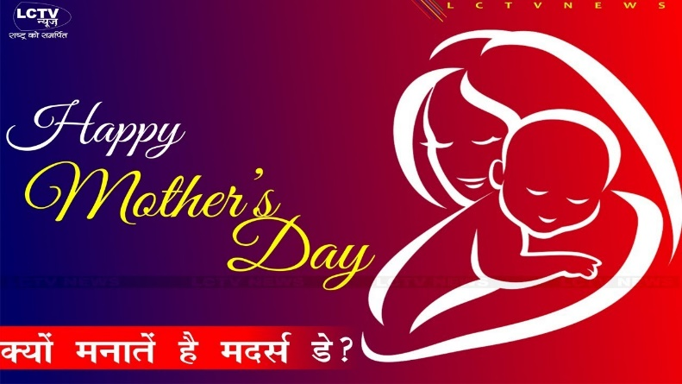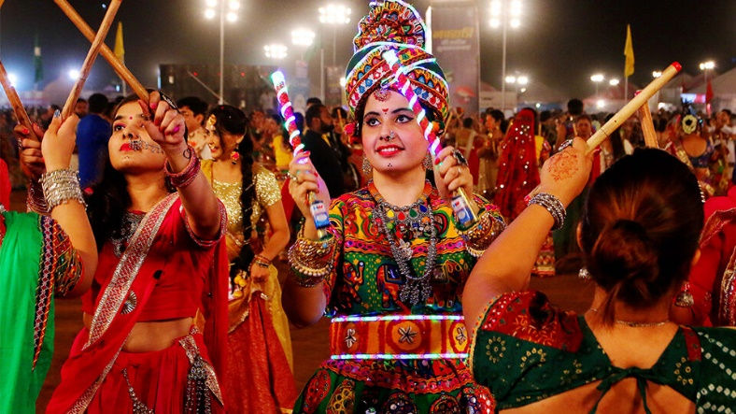

Urban India celebrates Mother’s Day on the same day as the USA, the second Sunday of every May. Children shower their moms with presents. Restaurants and retail stores offer discounts. However, most of rural India still remains unaware of this modern version of Mother’s Day. For them, the mother’s day has always been worshipping the female goddess Durga.
Traditionally, Indians have celebrated mothers and women during their 9-day Navratri festival or the 10-day Durga Puja that is held in October. People worship Mother Goddess Durga during this time and celebrate the triumph of good over evil. It is customary for families to get together, decorate their homes, spend time preparing goodies at home as well as eat outside. New clothes for everyone too! There is excitement in the air. In western India, you can see people dancing to the tunes of Garba music. While on the east coast, you will find people hopping around marquees and having lots of delicious street food.

Bring India home this Mother’s Day
Dance with your mom, wear new clothes and get her some nice gifts.
Dish up an Indian street food dish like Pani Puri. or make an Indian dessert. Mango kulfi is loved by all.

Arab World

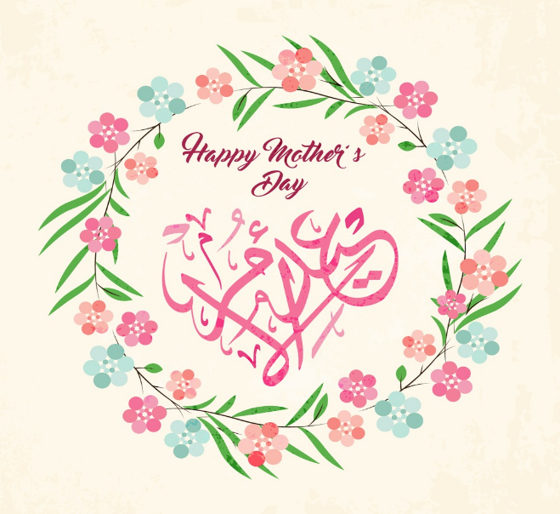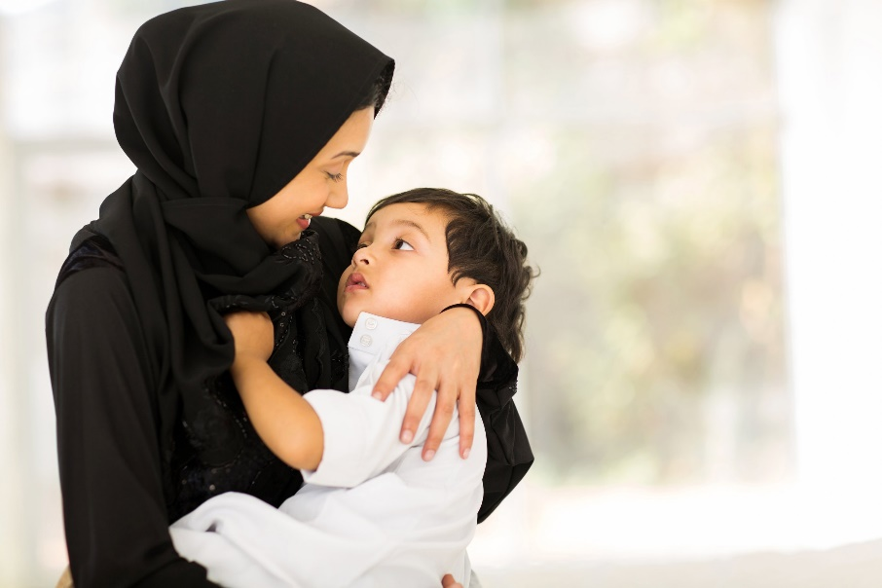

Arab countries in both Asia and Africa celebrate Mother’s Day on the 21st of March, the first day of spring when Mother Earth herself comes to life. It started in Egypt when a journalist tried to promote the idea of a day honoring the mothers of the country. The idea was initially ridiculed because it was a western concept. But then, slowly, it got accepted and spread to other Arab countries including Bahrain, UAE, Oman, Kuwait, and Iraq.
In the Arab world, this day celebrates not only biological mothers but every other motherly figure. That is why teachers at school receive a lot of mother’s day cards. At home, it is common for the children to kiss their mothers’ hands as a sign of love and affection. Mothers receive cards, flowers, and other presents. Grandmoms and mothers-in-law also receive gifts. It is also traditional for the family to dedicate a song (usually women-centric) to the mothers in the family.

Bring the Arab World home this Mother’s Day
Begin the day by kissing your mother’s hand and shower her with gifts.
Dedicate a loving song to your mother to show her how much she means in your life.

Isn’t this an exciting roundup of mother’s day traditions from around the world?
A single day or festival can mean so many different things across cultures. And that is exactly what these traditions show us. While for some, mother’s day signifies the beginning of spring and life, for others it is honoring women that are committed to changing lives. For many others, it is simply pampering that woman you love the most.

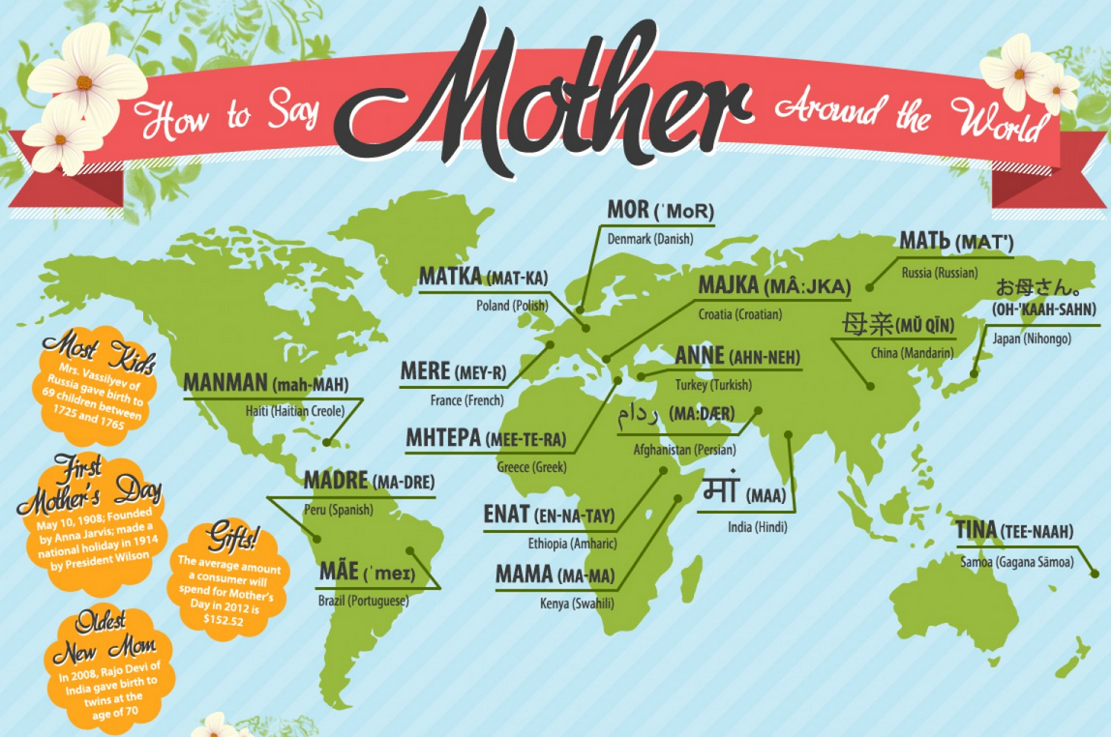

To be continued

«International Tourism», студенческая газета кафедры МККи МТ ГГУ им. Ф. Скорины, № 1.
Редколлегия: Аксёнчиков-Бирюков С.Ю.
Уважаемые студенты и преподаватели! Присылайте в редакцию нашей газеты стихи, фотоработы, статьи и заметки на электронный адрес: incontrovita@mail.ru
Наш адрес: 246019, г. Гомель, ул. Кирова, 119, аудитория 3-20

