INTERNATIONAL TOURISM
The Department of Intercultural Communication and International Tourism
May, 2023
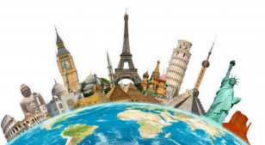
What’s new?
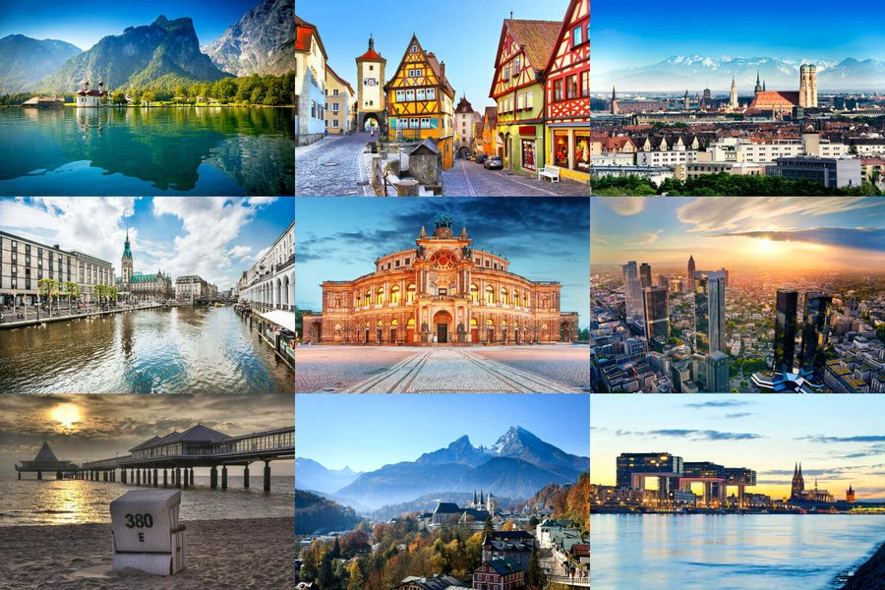
Today we will talk about Germany as our students learn German as a second foreign language. Germany has a lot to see - castles, museums, beautiful nature of Germany, picturesque landscapes, masterpieces of modern architects. You can go through the classic set of postcards from Germany: Brandenburg Gate, Neuschwanstein... Or choose for the next vacation not so obvious, but incredibly picturesque and popular places in Germany.
It’s almost summer outside, so the main theme is the places of Eco-Friendly tourism in Germany.
German Sightseeing
- Hiddensee
Günther Grass called this island in his novel «A Broad Field» Baltic Capri. Comparison is not accidental. The unincorporated owner of the island, writer Hauptmann, dreamed of his German Capri and found it on Hiddens.
The island was traditionally loved by the aristocracy and the bohemian. Thomas Mann and Albert Einstein stayed at Hauptmann. Sigmund Freud and Asta Nielsen came here to rest. There are practically no cars on the island, tourists and residents travel by bicycle, horse cart or on foot. Usually come here for the day to see the sights, admire the scenery and wander the narrow paths.
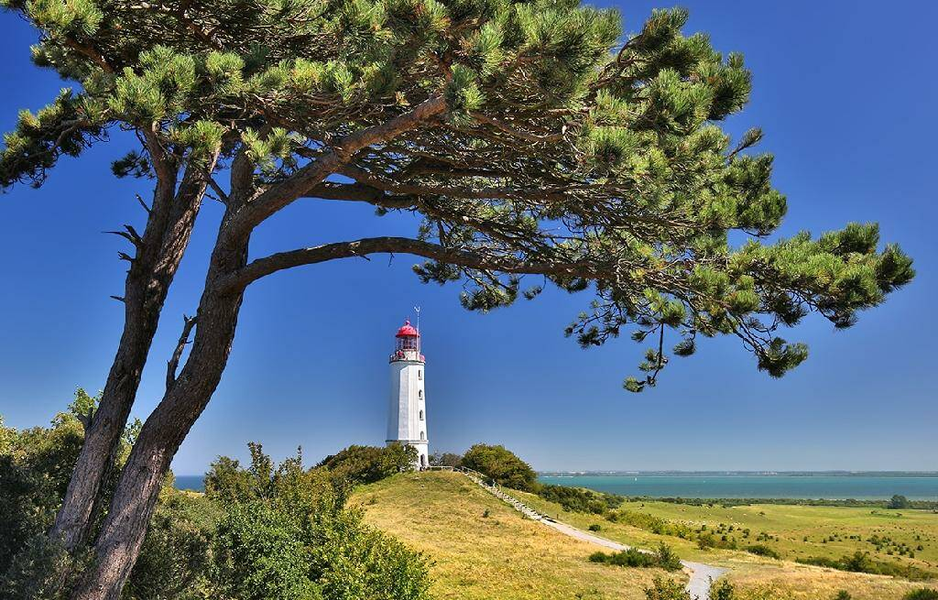
2. Shrek Lake (Schrecksee)
Despite its name, Lake Shrek has nothing to do with the cartoon character, except for the color of the surrounding mountains. Lake Shrek is surrounded by mountains and hills covered in greenery. This place is in the Bavarian Alps, and it can seem that it is pristine, untouched by human hands. There are no roads nearby, and the place can only be reached on foot. And you can't stay overnight at Shrek Lake, because camping is forbidden.
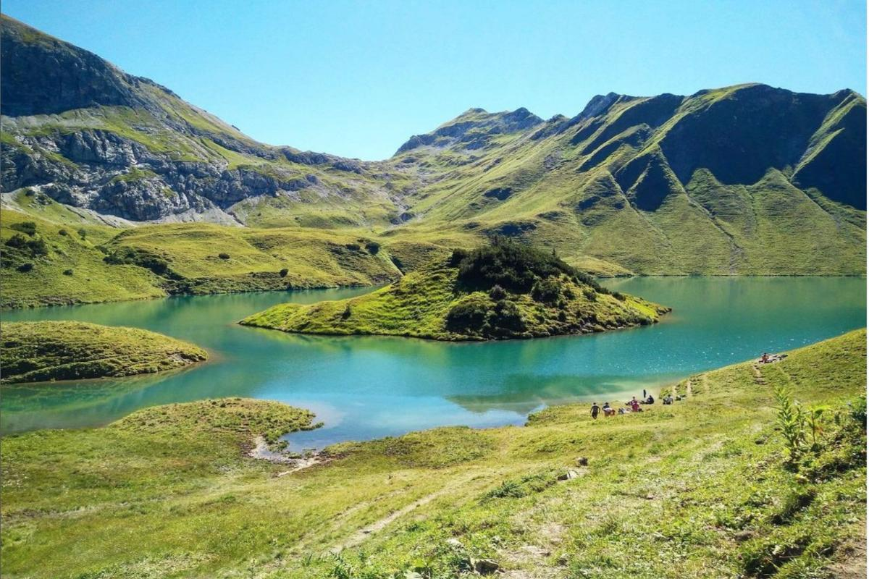
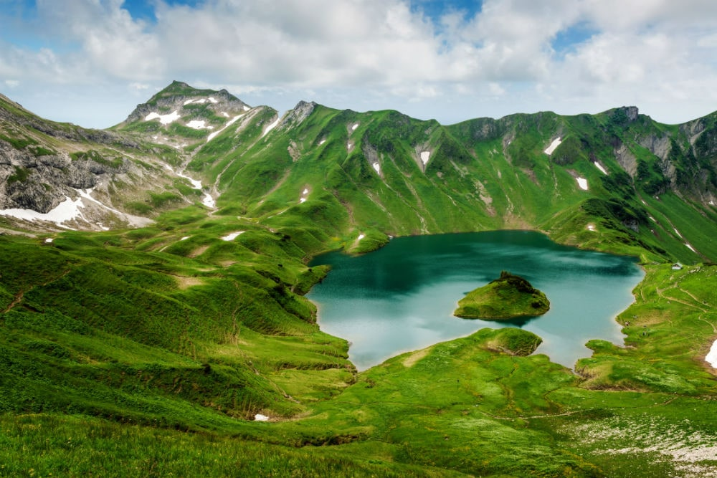
3. Park Kromlau (Rakotzbrücke in Kromlau)
Another picturesque place is located in eastern Germany near the Polish border. It is best to come here at the end of May or early June, when rhododendrons and azaleas are in bloom. In addition, there is one of the most photogenic bridges in the world - Rakotzbrücke (or Devil's Bridge), built in 1860. It is remarkable in that it forms a perfect circle with its reflection in the river. According to one legend, if one sails under the bridge on a full moon, without looking at his reflection and without touching the water, one can get the fulfillment of a cherished wish.

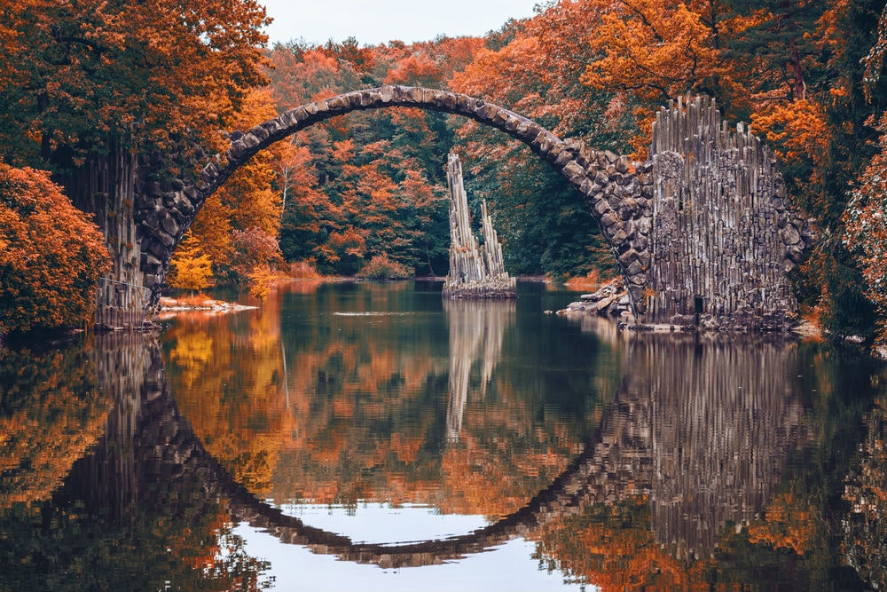

4. Bastei Bridge (Basteibrücke)

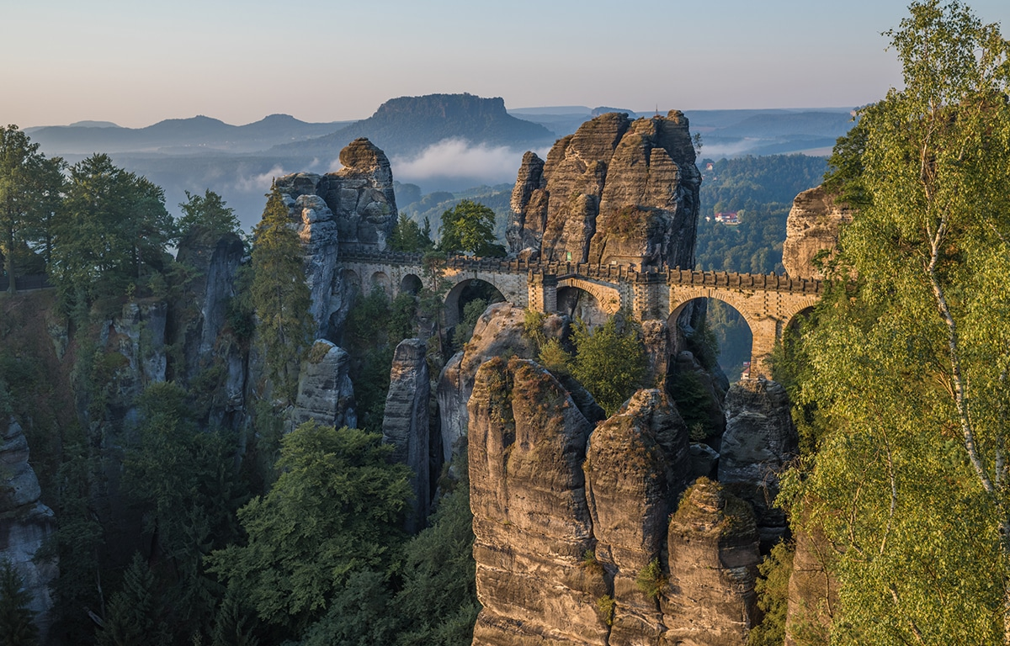

Bastay is a stone bridge in the national park Saxon Switzerland, located near the German-Czech border. It was originally built of wood in 1824 and replaced by sandstone in 1851. The surrounding cliffs rise above the Elbe River at 194 meters. Nearby you can also visit the medieval fortress of Koenigstein, which is located on the mountain of the same name.

