INTERNATIONAL TOURISM

The Department of Itercultural Communication and International Tourism

October, 2022
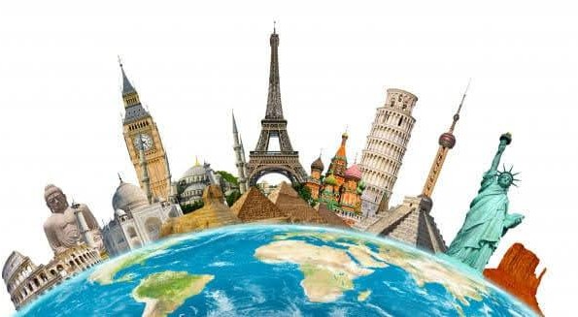
What’s new?
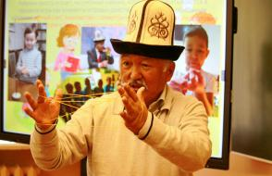
In October, 2022, classes on using the game in teaching as an element of folk education were held for the students of the Faculty of Phillology. The lecturer was Professor Umetov who works at the Department of Psychiatry, Medical Psychology and Narcology of the Akhunbaev Kyrgyz State Medical Academy.
Professor Umetov is a Doctor of education who has a profound knowledge in his specialty. He is an academician of the Academy of Pedagogical and Social Sciences of the Russian Federation and the International Aitmatov Academy.

The professor convincingly proved that a folk game is a very effective means of education. In his opinion, whenever games have different names, they are similar in all nations. The games of all the nations have no ethnic, state or administrative boundaries, so they are necessary for forming international relationships. The classes were very informative and exciting. Many thanks to Professor Umetov! We are looking forward for a very fruitful cooperation in the future!
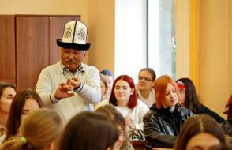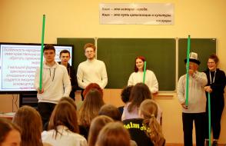

Mother's Day traditions across the world
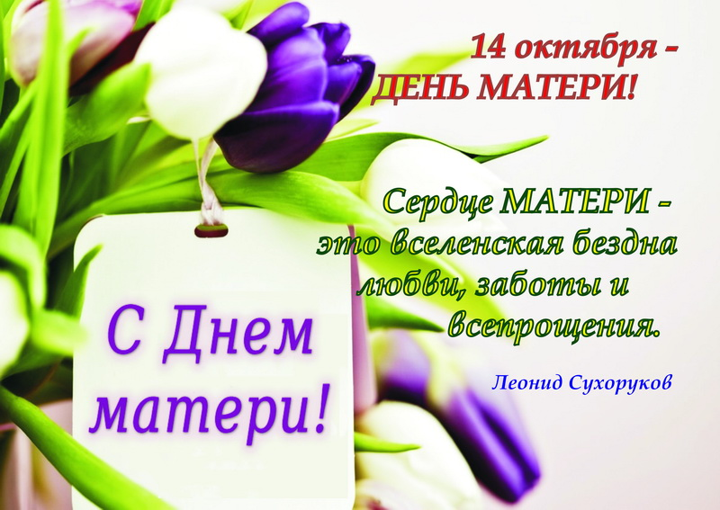
On the 14th of October Belarusians celebrate the Mother's Day, a holiday devoted to those formidable women who bring up children. On mother’s day, people make out the time to appreciate their mothers for their immense contributions to our lives. The relationship with the mother is more than any other in our life.
People are different, so are the traditions of holidays celebration, which sometimes are very unusual. We are going to make a trip around the world to see how people of different nations spend their time during the Mother's Day. Let's get started!
1. USA
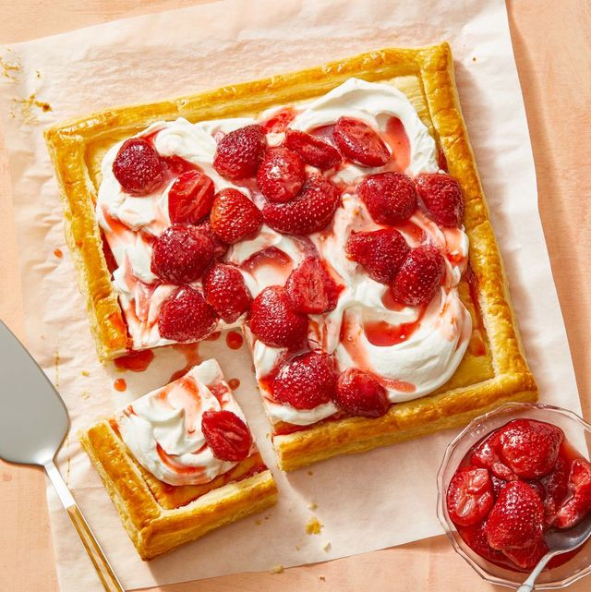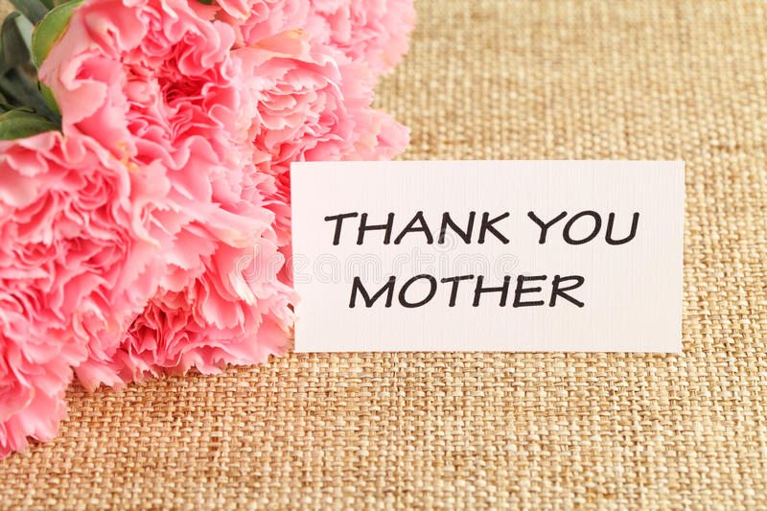
Mother’s Day is a very bright holiday in the USA. Mothers take the day off household work and kids cook them large, elaborate dinners. Or take them out for lunch to their favorite places. Carnations are the official Mother’s Day flowers in the USA! But honestly, people just buy the flower that their moms like.
Apart from gifting their moms with flowers, Americans also wear flower corsages on Mother’s Day. This is a custom unique to the USA. Wearing pink carnation honors a living mother while wearing white carnation honors a deceased one.
2. Finland
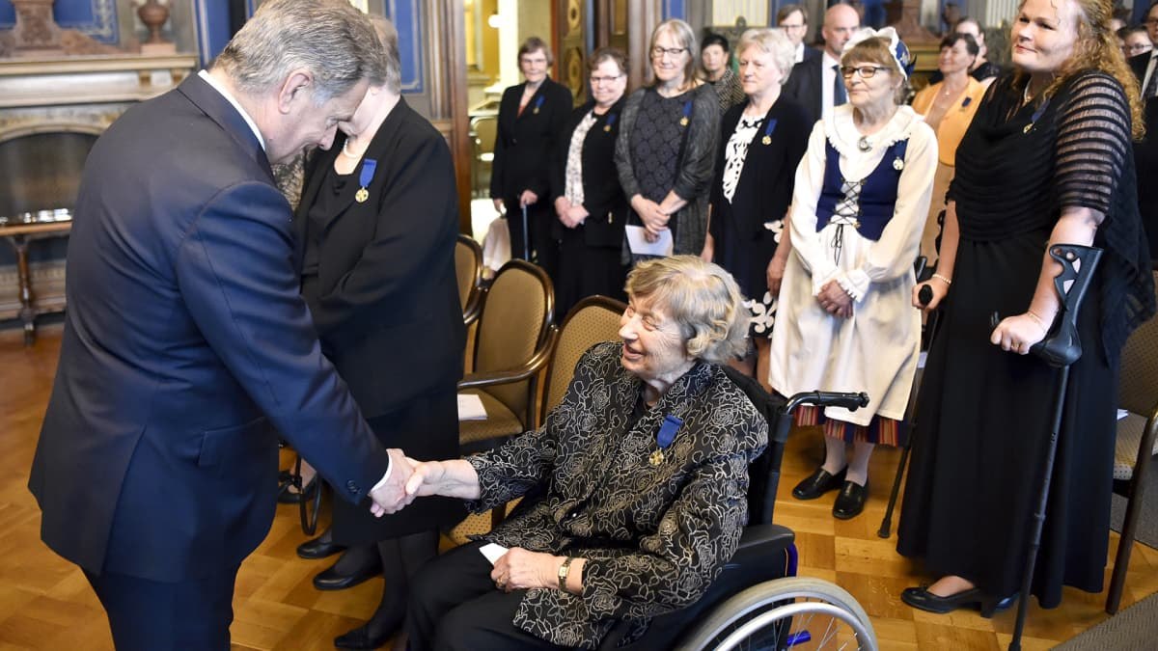 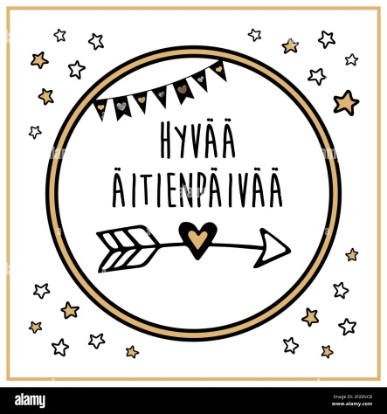

Mother’s Day in Finland is celebrated on the second Sunday in May. It is an official flag day, meaning that the Finnish flag must be flown from public buildings on this day.
On Mother’s day the Finnish president does his or her part too. Each year, the leader honors a group of exemplary mothers who have been nominated by their families or communities. Recent picks include single moms, foster moms, and moms who raised children with special needs.
3. Mexico
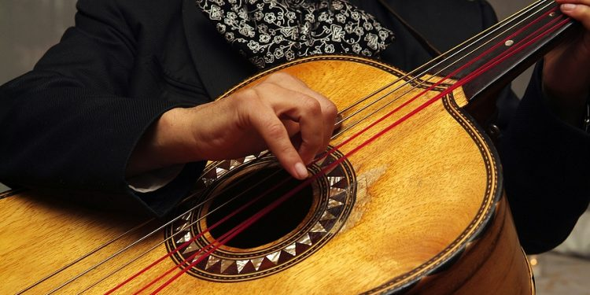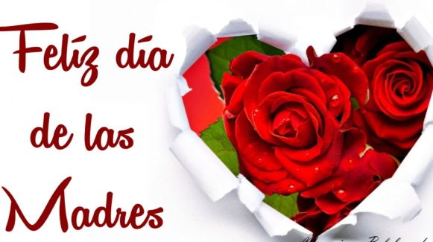
In Mexico the Mother's Day is celebrated on the 10th of May each year. According to tradition, the festivals start in the morning when children serenade Moms with the song “Las Mañanitas." Professional mariachi bands are also known to sing this song all day long.
The English translation goes like this:
These are little mornings
That King David used to sing
And on the day of your Saint
We sing them to you.
Wake up, my dear, wake up!
Look, it’s already dawning,
The little birds are already singing
The moon has gone away.

4. Ethiopia
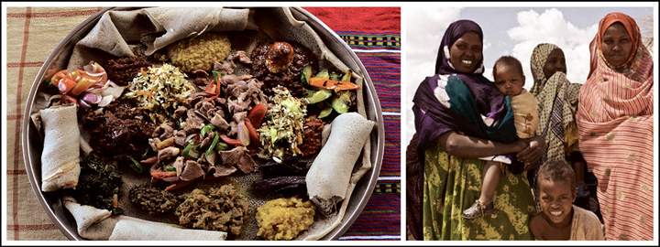
In Ethiopia, the mothers get three whole days devoted to them. (Not a bad idea!) And during the multi-day feast, known as Antrosht, which starts when the rainy season ends (some time in mid-fall), people celebrate by preparing traditional Ethiopian hash — and it's a joint effort. Girls provide the spices and dairy, and boys prepare the meat. Then, the mother cooks up the massive meal, which is followed by singing and dancing.
5. Serbia
In the southeastern European country, “Mother's Day" is called Materice, and it is celebrated on the second Sunday before Christmas. Mamas are awoken to their children gently binding their feet with ribbon or string, and she must remain tied up until she gives them small presents and treats.
However, mothers aren’t the only ones tied up on their day of celebration. A week earlier on Children’s Day, children are tied up and must agree to behave before they are released. A week after Mother’s Day, the fathers are tied up and until they present gifts on Father’s Day.
6. Japan
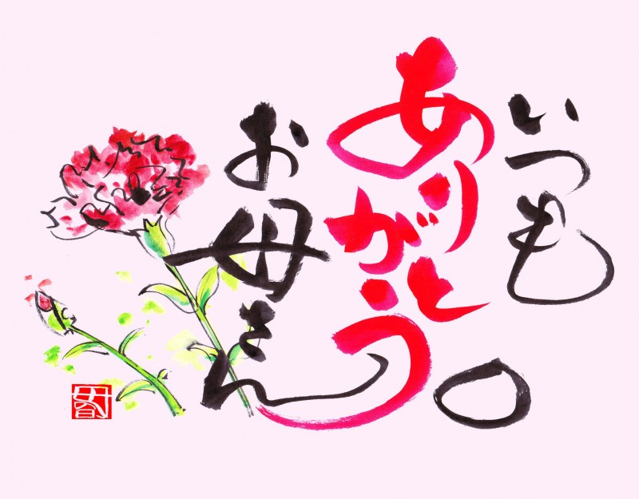
Japan does celebrate Mother’s Day, which translates as ‘Haha No Hi’, on the 8th of May. In Japan, a popular ritual on Mother’s Day is for children to draw pictures of their mothers. Those pictures can be posted on windows at stores or submitted for art competitions, with the selected winners having their pictures displayed at exhibits across the country and possibly in other parts of the world.

7. Paraguay
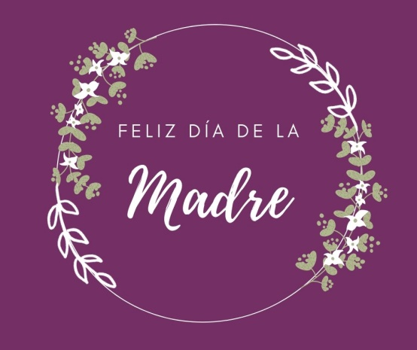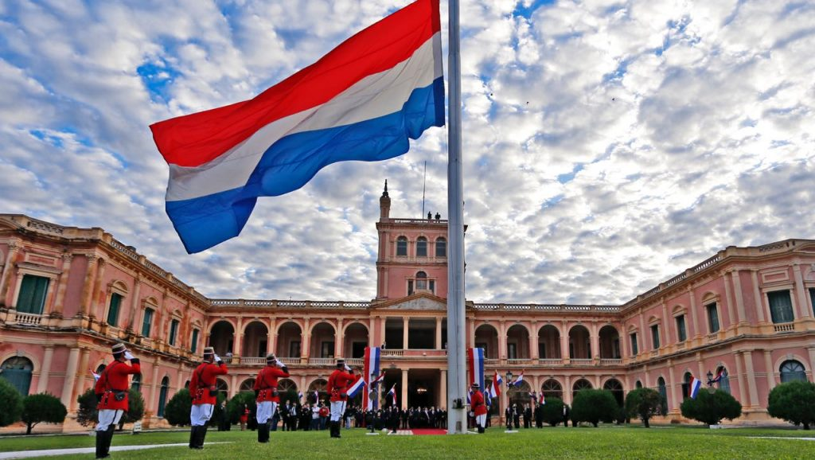
Paraguay is the only country to celebrate Mother´s Day on May 15, which is also the Independence Day of the country. There have been some efforts to move Mother´s Day as it is much more popular than the Independence Day but so far, these two holidays stay un-separated.
8. Belgium
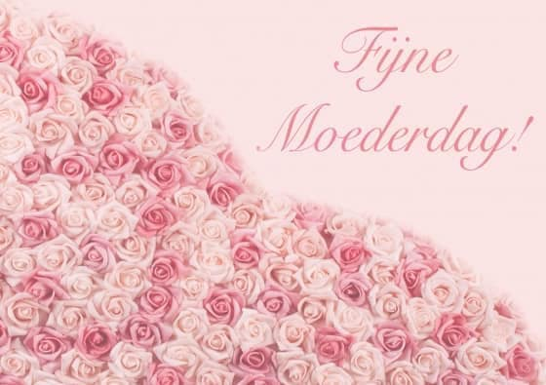
In Belgium, Mother´s Day is celebrated on two different days. Most of the country celebrate it on the second Sunday of May but there are also many people who do it on August 15. Renowned for its delicious chocolate, Belgium is where mothers are mostly given chocolates, pastries and other sweets.

9. Thailand
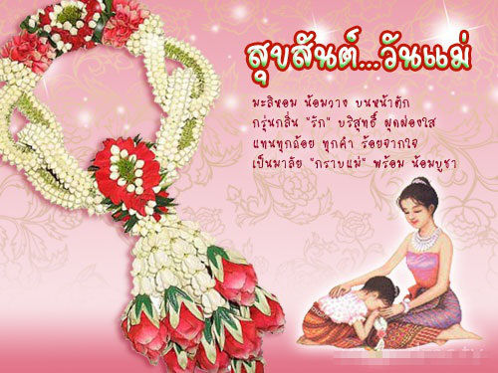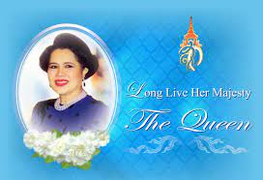
The Mother's Day doesn't have such popularity in Thailand but it is becoming a significant holiday. Thai people celebrate it on August 12 which is the Thai Queen Sirikit´s birthday. Similarly, Father´s Day is celebrated on the King´s birthday.
10. Nepal
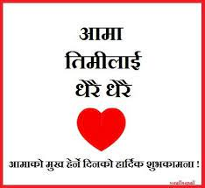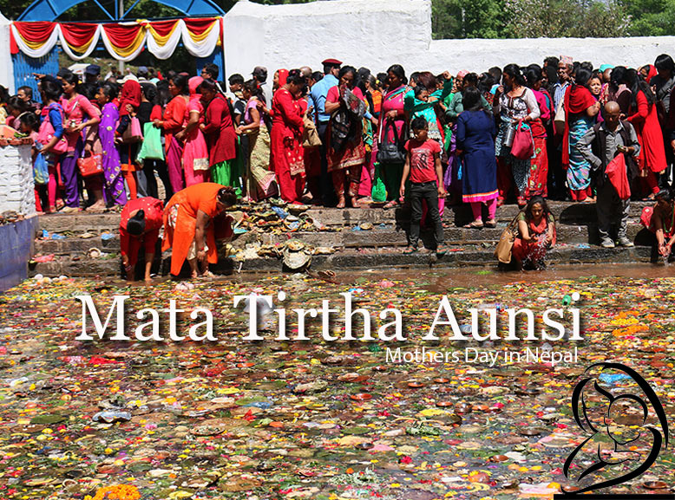
In Nepal, the equivalent of Mother´s Day is called “Mata Tirtha Aunsi“ (meaning “Mother Pilgrimage New Moon”) and it’s celebrated on the last day of the dark fortnight in the month of Baishakh which falls in April or May. Traditionally, Nepal people give gifts to their living mothers and, to honor the deceased, they go on a pilgrimage.

To be continued

«International Tourism», студенческая газета кафедры МККи МТ ГГУ им. Ф. Скорины, № 1.
Редколлегия: Аксёнчиков-Бирюков С.Ю.
Уважаемые студенты и преподаватели! Присылайте в редакцию нашей газеты стихи, фотоработы, статьи и заметки на электронный адрес: incontrovita@mail.ru
Наш адрес: 246019, г. Гомель, ул. Кирова, 119, аудитория 3-20

