Psychology study
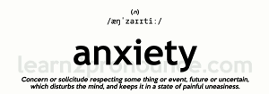

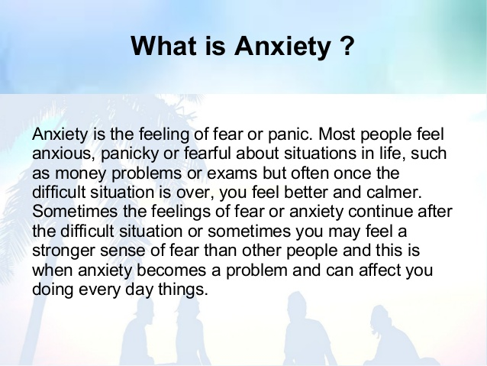
It can be:
-genetic
- environmental
- biological
- psychologically determined
- cause by neurotransmitter imbalances.
Most epidemiological population studies have demonstrated that women suffer more anxiety and depression than men. A higher level of stress, greater vulnerability to stress, and a non-additive effect of private/domestic and occupational obligations on women have been suggested as an explanation. A cross-sectional, random sample of the population resulted in 651 men and 626 women, all of whom were employed, participating in the study. Participants were interviewed using face-to-face standardized questionnaires. Younger women experienced more stressful relationship events, illness events and network events than men of the same age. Relationship events were more important for men as they grew older, and interacted with other stress to increase anxiety and depression symptoms. Stressful illness events were more strongly related to anxiety/depression symptoms in women over 40 than in men of the same age, and interacted with work stress to increase symptom scores.
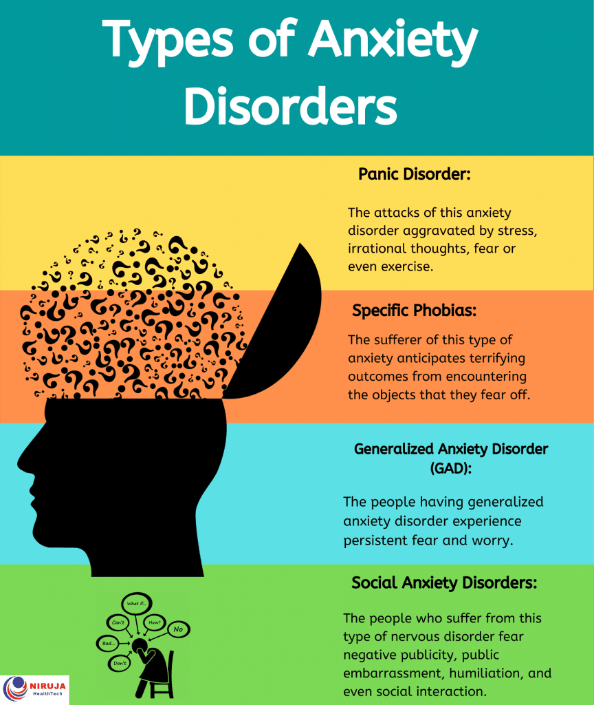

Diagnostic Criteria for Generalized Anxiety Disorder
A. Excessive anxiety and worry (apprehensive expectation), occurring more days than not for at least 6 months, about a number of events or activities (such as work or school performance).
B. The individual finds it difficult to control the worry.
C. The anxiety and worry are associated with three (or more) of the following six symptoms (with at least some symptoms having been present for more days than not for the past 6 months):
Note: Only one item is required in children.
1. Restlessness or feeling keyed up or on edge.
2. Being easily fatigued.
3. Difficulty concentrating or mind going blank.
4. Irritability.
5. Muscle tension.
6. Sleep disturbance (difficulty falling or staying asleep, or restless, unsatisfying sleep).
D. The anxiety, worry, or physical symptoms cause clinically significant distress or impairment in social, occupational, or other important areas of functioning.
E. The disturbance is not attributable to the physiological effects of a substance (e.g., a drug of abuse, a medication) or another medical condition (e.g., hyperthyroidism).
F. The disturbance is not better explained by another mental disorder (e.g., anxiety or worry about having panic attacks in panic disorder, negative evaluation in social anxiety disorder [social phobia], contamination or other obsessions in obsessive-compulsive disorder, separation from attachment figures in separation anxiety disorder, reminders of traumatic events in posttraumatic stress disorder, gaining weight in anorexia nervosa, physical complaints in somatic symptom disorder, perceived appearance flaws in body dysmorphic disorder, having a serious illness in illness anxiety disorder, or the content of delusional beliefs in schizophrenia or delusional disorder).
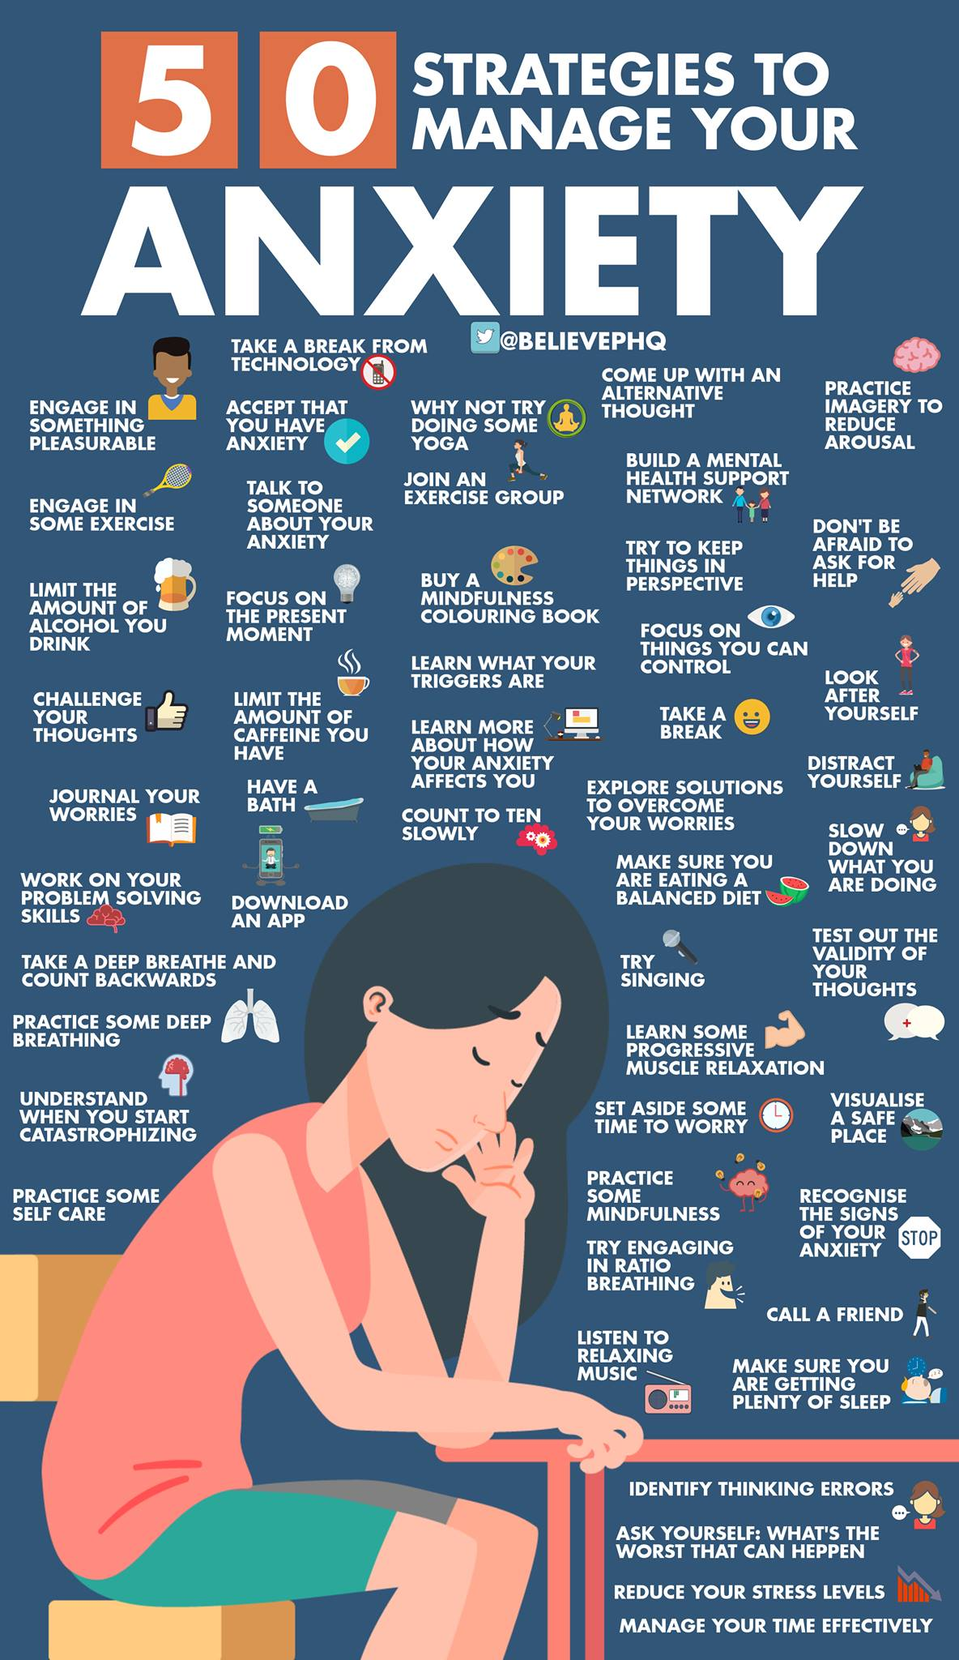

Anxiety test
Начало формы

1.How often have you been bothered by feeling nervous, anxious or on edge over the last two weeks?
NOT AT ALL SEVERAL DAYS MORE THAN HALF THE DAYS NEARLY EVERY DAY

2.How often have you been bothered by not being able to stop or control worrying over the last two weeks?
NOT AT ALL SEVERAL DAYS MORE THAN HALF THE DAYS NEARLY EVERY DAY
3.How often have you been bothered by worrying too much about different things over the last two weeks?
NOT AT ALL SEVERAL DAYS MORE THAN HALF THE DAYS NEARLY EVERY DAY
4.How often have you been bothered by having trouble relaxing over the last two weeks?
NOT AT ALL SEVERAL DAYS MORE THAN HALF THE DAYS NEARLY EVERY DAY

5.How often have you been bothered by being so restless that it is hard to sit still over the last two weeks?
NOT AT ALL SEVERAL DAYS MORE THAN HALF THE DAYS NEARLY EVERY DAY

6.How often have you been bothered by becoming easily annoyed or irritable over the last two weeks?
NOT AT ALL SEVERAL DAYS MORE THAN HALF THE DAYS NEARLY EVERY DAY

7.How often have you been bothered by feeling afraid as if something awful might happen over the last two weeks?
NOT AT ALL SEVERAL DAYS MORE THAN HALF THE DAYS NEARLY EVERY DAY

Газета подготовлена старшим преподавателем кафедры английского языка Акулич Ю.Е. и студентами групп Пс-11, Пс-12

